COMPARATIVE EFFECTIVENESS OF PREVENTIVE AND THERAPEUTIC INTERVENTIONS FOR RADIOTHERAPY-RELATED XEROSTOMIA IN HEAD AND NECK CANCER PATIENTS: A SYSTEMATIC REVIEW AND NETWORK META-ANALYSIS

ABSTRACT
Radiotherapy-related xerostomia is one of the side effects frequently experienced by patients with head and neck cancer. This condition can interfere with eating, swallowing, speaking, sleeping, nutritional status, and patients’ quality of life. This study aims to analyze and compare the effectiveness of preventive and therapeutic interventions for radiotherapy-related xerostomia in patients with head and neck cancer through a systematic literature review and network meta-analysis. Articles were obtained from PubMed/MEDLINE, Scopus, and Web of Science using the criteria of primary articles published from 2017 onward, involving patients with head and neck cancer, discussing radiotherapy-related xerostomia, and evaluating preventive or therapeutic interventions. A total of 12 articles met the inclusion criteria. The interventions analyzed included acupuncture, photobiomodulation, saliva substitutes, oral sprays, mouthwashes, transcutaneous electrical nerve stimulation, salivary electrostimulation, and thyme honey. The results showed that most interventions demonstrated a positive direction of effect in reducing xerostomia symptoms or improving salivary function. The pooled effect showed a value of 1.26 with a confidence interval of 0.78–1.74 and p < 0.001. The heterogeneity value of I² was 53.51%, indicating moderate variation among the articles. Acupuncture, saliva substitutes, and oral moisturizers showed relatively consistent results. Photobiomodulation and electrical stimulation showed more varied results. This study emphasizes that the selection of interventions should be adjusted according to the treatment phase, severity of symptoms, and the patient’s salivary function condition.
Keywords: xerostomia; radiotherapy; head and neck cancer; preventive interventions

INTRODUCTION
Head and neck cancer remains a major clinical problem because its disease burden continues to be evident in global oncology services. Sun et al. (2025) reported that head and neck cancer accounted for approximately 947,211 new cases and 482,428 deaths in 2022. These figures indicate that cancers of the oral cavity, pharynx, larynx, nasopharynx, oropharynx, hypopharynx, and salivary glands still require strong attention, not only in terms of tumor control but also in relation to treatment-related adverse effects. Radiotherapy is one of the main treatment modalities because it can be administered as definitive therapy, as adjuvant therapy after surgery, or in combination with chemotherapy for patients with locally advanced disease. The success of radiotherapy increases patients’ survival opportunities, but radiation exposure to healthy tissues surrounding the tumor may cause persistent disturbances in the mucosa, teeth, swallowing muscles, and salivary glands. This problem means that the effectiveness of cancer therapy should not be assessed solely based on tumor response, but also on patients’ quality of life after treatment has been completed.
Radiotherapy-related xerostomia is one of the most frequently reported adverse effects among patients with head and neck cancer. Hong et al. (2024) distinguished xerostomia as a subjective sensation of dry mouth and salivary gland hypofunction as an objective reduction in salivary secretion. This distinction is important because patients’ complaints do not always correspond to measured salivary flow rates. Salivary gland damage may occur when the parotid, submandibular, or minor salivary glands are exposed to radiation doses. Mercadante et al. (2017) stated that radiation-induced salivary gland damage may occur in 63–93% of patients when the salivary glands are located within the radiation field. Garcia et al. (2019) also emphasized that more than 50% of patients undergoing radiotherapy with salivary gland exposure experience a perception of hyposalivation at the end of treatment. This impact often develops into chronic complaints, especially among patients who have completed radiotherapy for more than one year.
Xerostomia does not merely cause discomfort. This complaint can change how patients eat, speak, sleep, maintain oral hygiene, and preserve their nutritional status. Jaguar et al. (2017) reported that post-radiotherapy xerostomia increases the risk of dental caries, chewing difficulties, swallowing disorders, and sleep disturbances. Alnaeem et al. (2025) also described xerostomia as a complaint associated with dysphagia, decreased nutritional status, poor sleep quality, and reduced quality of life in patients with head and neck cancer. Nathan et al. (2023) even identified xerostomia as one of the main causes of reduced quality of life among head and neck cancer survivors who received radiation, with its effects still experienced by many patients after treatment completion. These facts show that xerostomia should be understood as a clinically significant outcome, not merely as a mild complaint following radiotherapy.
Efforts to prevent xerostomia have developed through tissue-sparing radiotherapy techniques, radioprotectants, sialogogues, acupuncture, bethanechol, photobiomodulation therapy, and surgical approaches such as submandibular gland transfer in selected cases. Mercadante et al. (2021), through the ISOO/MASCC/ASCO guideline, emphasized that tissue-sparing radiation modalities have high-quality evidence for preventing salivary gland hypofunction and xerostomia in patients with head and neck cancer. The guideline also stated that bethanechol and acupuncture may be offered during radiotherapy to reduce the risk of xerostomia, although the strength of evidence is not as strong as that for tissue-sparing radiotherapy techniques. Louzeiro et al. (2020), through a meta-analysis, showed that photobiomodulation therapy has the potential to minimize radiation-induced hyposalivation, particularly by increasing both unstimulated and stimulated salivary flow. Garcia et al. (2019) demonstrated that acupuncture administered during radiotherapy resulted in lower xerostomia scores at 12 months compared with standard care, although the difference compared with sham acupuncture was not always strong.
Therapeutic interventions for established xerostomia also show varied directions of evidence. Mercadante et al. (2017) concluded that pilocarpine and cevimeline may serve as first-line therapies for head and neck cancer survivors with post-radiotherapy xerostomia and hyposalivation. Yang et al. (2016) found that pilocarpine administration during radiation could increase unstimulated salivary flow rates and reduce clinician-rated xerostomia severity, although patient-reported outcomes did not always improve within the first three months. Gu et al. (2014) showed that amifostine could reduce the risk of acute and late xerostomia in patients with head and neck cancer undergoing radiotherapy, but its clinical use still needs to consider adverse effects and patient acceptance. Nakamura et al. (2023) assessed bethanechol chloride as potentially beneficial for patients with xerostomia and hyposalivation, while Hong et al. (2024) emphasized that symptom management can be approached in two main ways: stimulating saliva production in glands that still retain secretory capacity and providing artificial lubrication of the oral surfaces.
Recent evidence also shows that non-pharmacological interventions are receiving greater attention. Ni et al. (2020) concluded that acupuncture may improve xerostomia symptoms, but it has not shown a consistent effect on objective measurements of salivary flow. Tsai et al. (2025) stated that acupuncture may serve as a complementary therapy to reduce dry mouth symptoms and improve quality of life, but treatment protocols still need to be standardized so that benefits can be compared across studies. Cohen et al. (2024), through a multicenter clinical trial, showed that true acupuncture was more effective than sham acupuncture and standard oral hygiene for managing chronic xerostomia one year or more after radiotherapy. These findings strengthen the potential of non-pharmacological therapies, but they also reveal an important issue in evidence synthesis, namely differences in clinical trial design, timing of intervention, type of comparator, measurement of xerostomia, and duration of follow-up.
Research gaps remain clearly visible. Mercadante et al. (2021) provided an evidence-based guideline, but the guideline combined older and newer evidence up to June 2020 and did not focus on quantitative comparisons of all preventive and therapeutic interventions. Mercadante et al. (2017) evaluated various interventions for the management of xerostomia and hyposalivation, but developments in interventions such as photobiomodulation therapy, multicenter acupuncture trials, variations of pilocarpine, and recent evaluations of non-pharmacological therapies were not fully covered. Louzeiro et al. (2020), Ni et al. (2020), Tsai et al. (2025), and Shrateh et al. (2025) made important contributions, but their focus remained separated by specific modalities or treatment options. Few reviews have simultaneously mapped evidence on prevention and treatment and then compared their effectiveness through subjective outcomes, salivary flow rates, quality of life, and adverse effects. This gap is important because clinicians need a stronger basis for selecting interventions according to the patient’s clinical phase, namely before xerostomia appears, during therapy, and after the complaint persists as a late effect.
The study entitled Comparative Effectiveness of Preventive and Therapeutic Interventions for Radiotherapy-Related Xerostomia in Head and Neck Cancer Patients is relevant because a systematic literature review and meta-analysis can summarize the direction of scattered evidence, assess the methodological quality of previous studies, compare effect sizes across interventions, and distinguish the meaning of subjective and objective outcomes. This approach can also help determine whether an intervention is stronger as a preventive measure, more appropriate as a therapy after xerostomia has occurred, or only provides improvement in certain aspects such as oral comfort without restoring salivary flow rates. In this way, evidence synthesis does not merely provide a literature summary, but also serves as a clinical basis for prioritizing interventions that are safe, realistic, and valuable for patients with head and neck cancer. The objective of this study is to analyze and compare the effectiveness of preventive and therapeutic interventions for radiotherapy-related xerostomia in patients with head and neck cancer through a systematic literature review and meta-analysis.

RESEARCH METHOD
This study employed a systematic literature review and meta-analysis design to analyze the effectiveness of preventive and therapeutic interventions for radiotherapy-related xerostomia in patients with head and neck cancer. This design was selected because the study does not merely map previous articles, but also combines quantitative data from primary studies to obtain a stronger effect estimate regarding interventions that can reduce the incidence of xerostomia, improve dry mouth complaints, increase salivary flow rate, and support patients’ quality of life. The reporting of this study refers to the PRISMA 2020 guidelines, as these guidelines are used to clarify the process of identifying, selecting, assessing eligibility, and including scientific articles in systematic reviews and meta-analyses. Page et al. (2021) explain that PRISMA 2020 was designed for reporting systematic reviews that evaluate the effects of health interventions.
The quantitative analysis was conducted by referring to the principles of meta-analysis in clinical research, namely the combination of effect sizes from several primary studies with comparable populations, interventions, comparators, and outcomes. Higgins et al. (2024) explain that meta-analysis is used to combine the results of several studies through the selection of effect measures, calculation of pooled estimates, and assessment of variations in results across studies. This study focused on articles that reported statistical data in the form of odds ratios (OR), p-values, and confidence intervals (CI), or event data that could be converted into OR. In this way, the results of the study are not limited to literature mapping, but also provide statistical estimates regarding the effectiveness of preventive and therapeutic interventions for radiotherapy-induced xerostomia in patients with head and neck cancer.
The stages of the study included: (1) formulation of the research question based on PICO, (2) article searches in scientific databases, (3) article selection based on inclusion and exclusion criteria, (4) quantitative data extraction, (5) effect size calculation, (6) heterogeneity analysis, and (7) interpretation of the meta-analysis results. The article search process was conducted systematically in three major databases most relevant to oncology, radiotherapy, dentistry, and cancer supportive care, namely PubMed/MEDLINE, Scopus, and Web of Science. The search was limited to articles published from 2017 onward, articles written in English and/or Indonesian, peer-reviewed articles, and primary studies with randomized controlled trial, quasi-experimental study, prospective clinical study, retrospective comparative study, and controlled clinical trial designs. Articles in the form of systematic reviews, scoping reviews, meta-analyses, narrative reviews, editorials, letters to the editor, case reports, and case series were not included as primary data because they do not provide primary data suitable for effect size calculation.
The development of keywords was carried out using the PICO approach as follows.

Table 1. Research PICO
Component | Description
P (Population) | Head and neck cancer patients who are undergoing or have undergone radiotherapy, either radiotherapy alone or in combination with chemotherapy.
I (Intervention) | Preventive and therapeutic interventions for xerostomia, such as pilocarpine, cevimeline, bethanechol, amifostine, acupuncture, photobiomodulation therapy, intensity-modulated radiotherapy, saliva substitute, oral lubricant, submandibular gland transfer, and supportive oral care.
C (Comparison) | Placebo, sham intervention, standard care, standard oral hygiene, no intervention, or other comparator interventions.
O (Outcome) | Xerostomia, severity of xerostomia, improvement of dry mouth symptoms, reduction in severe xerostomia, stimulated and unstimulated salivary flow rates, quality of life, and adverse effects of the intervention.

Keywords were combined using the Boolean operators AND and OR. The main search strategy was designed to obtain articles discussing head and neck cancer, radiotherapy, xerostomia, preventive interventions, therapeutic interventions, and statistical data that could be used for meta-analysis.
Table 2. Number of Articles Based on Search Databases
Database | Keyword | Number of Articles
PubMed/MEDLINE | (“head and neck cancer” OR “head and neck neoplasms” OR “oral cancer” OR “nasopharyngeal cancer” OR “oropharyngeal cancer”) AND (radiotherapy OR radiation OR “radiation therapy” OR chemoradiotherapy) AND (xerostomia OR “dry mouth” OR “salivary hypofunction” OR hyposalivation) AND (pilocarpine OR cevimeline OR bethanechol OR amifostine OR acupuncture OR “photobiomodulation” OR “low-level laser therapy” OR “intensity-modulated radiotherapy” OR IMRT OR “saliva substitute” OR “oral lubricant” OR “submandibular gland transfer”) AND (“odds ratio” OR “confidence interval” OR “p value” OR trial OR intervention) | 96
Scopus | TITLE-ABS-KEY (“head and neck cancer” OR “head and neck neoplasm” OR “oral cancer” OR “nasopharyngeal cancer” OR “oropharyngeal cancer”) AND TITLE-ABS-KEY (radiotherapy OR radiation OR chemoradiotherapy) AND TITLE-ABS-KEY (xerostomia OR “dry mouth” OR hyposalivation OR “salivary gland hypofunction”) AND TITLE-ABS-KEY (pilocarpine OR cevimeline OR bethanechol OR amifostine OR acupuncture OR photobiomodulation OR “low-level laser therapy” OR IMRT OR “saliva substitute” OR “oral lubricant”) AND PUBYEAR > 2016 | 118
Web of Science | TS=(“head and neck cancer” OR “head and neck neoplasms” OR “oral cancer” OR “nasopharyngeal cancer” OR “oropharyngeal cancer”) AND TS=(radiotherapy OR radiation OR chemoradiotherapy) AND TS=(xerostomia OR “dry mouth” OR hyposalivation OR “salivary gland hypofunction”) AND TS=(pilocarpine OR cevimeline OR bethanechol OR amifostine OR acupuncture OR photobiomodulation OR “low-level laser therapy” OR IMRT OR “saliva substitute” OR “oral lubricant” OR “submandibular gland transfer”) | 82
Total articles identified |  | 296

The initial search process in PubMed/MEDLINE, Scopus, and Web of Science yielded 296 articles, consisting of 96 articles from PubMed/MEDLINE, 118 articles from Scopus, and 82 articles from Web of Science. After duplicate checking was conducted, 5 duplicate articles were identified, leaving 291 articles for the title and abstract screening stage. At this stage, 224 articles were excluded because they were not aligned with the research focus, did not discuss head and neck cancer patients, did not evaluate radiotherapy-related xerostomia, did not include preventive or therapeutic interventions, did not provide OR, p-value, and CI data, or had inappropriate publication designs such as reviews, editorials, case reports, and case series. Therefore, 67 articles proceeded to the full-text assessment stage.
The PRISMA diagram was used to illustrate the number of articles obtained from each database, the duplicate articles removed, the articles excluded during the screening stage, the articles assessed in full text, and the final articles included in the qualitative synthesis and quantitative meta-analysis.
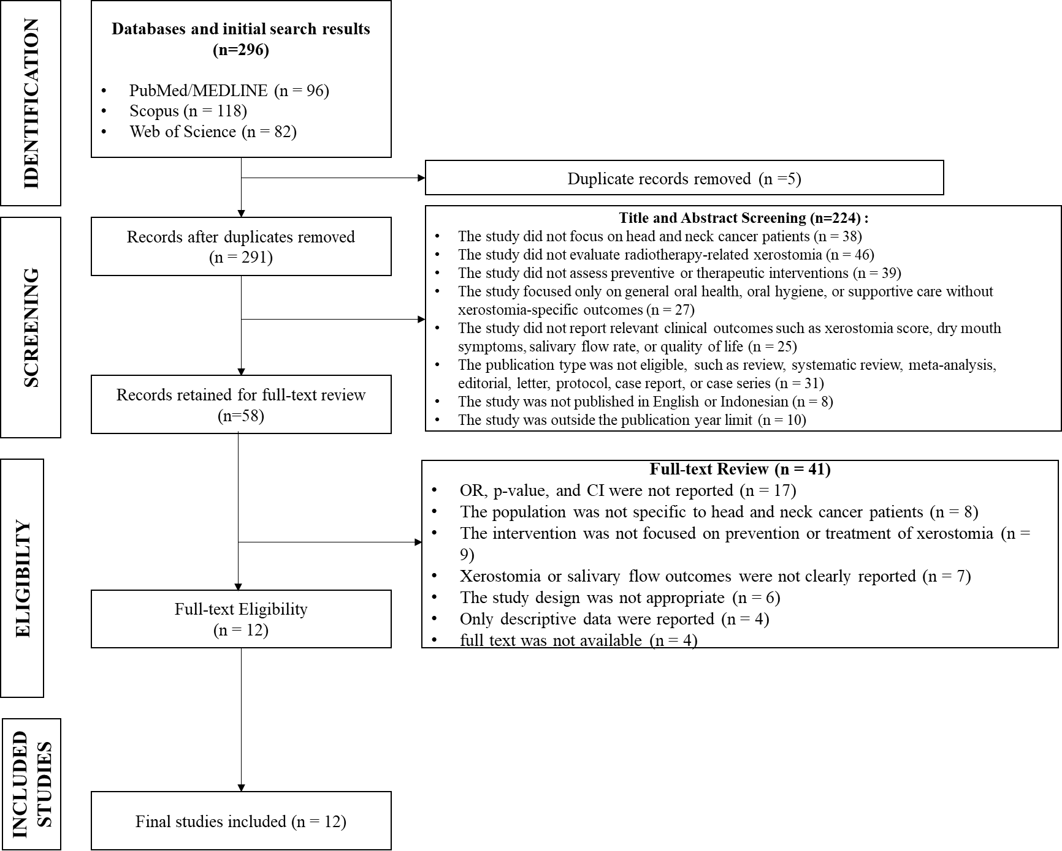
Figure 1. PRISMA Diagram
At the full-text evaluation stage, 55 articles were excluded for several reasons: 17 articles did not report OR, p-value, and CI; 8 articles had populations that were not specific to head and neck cancer patients; 9 articles did not focus on interventions for the prevention or treatment of xerostomia; 7 articles did not clearly report xerostomia outcomes or salivary flow rate; 6 articles had inappropriate study designs; 4 articles only reported descriptive data without a comparator; and 4 articles did not have full-text availability. After the entire selection process was completed, 12 articles met the inclusion criteria and were included in the meta-analysis.
The inclusion criteria in this study were as follows: (1) articles published in 2017 or later; (2) articles were primary quantitative studies; (3) the study population consisted of head and neck cancer patients who were undergoing or had undergone radiotherapy; (4) articles discussed preventive or therapeutic interventions for radiotherapy-related xerostomia; (5) articles included a comparison group, such as placebo, sham intervention, standard care, no intervention, or another intervention; (6) articles reported OR, p-value, and CI or provided data that could be calculated into OR; (7) articles were available in full text; and (8) articles were written in English or Indonesian. The exclusion criteria included: (1) articles in the form of reviews, systematic reviews, meta-analyses, editorials, letters, protocols, case reports, or case series; (2) articles that did not separate data on head and neck cancer patients from other cancer populations; (3) articles that only discussed biological mechanisms without clinical outcomes; (4) articles that did not report xerostomia outcomes, salivary flow rate, or quality of life; (5) articles that did not provide OR, p-value, and CI; and (6) duplicate articles from the same dataset.
A fixed-effect model was used when heterogeneity was low, whereas a random-effects model was applied when the I² value indicated high variation across articles. The I² value was used to assess the degree of heterogeneity among study findings, while the p-value was used to determine the significance of the pooled results. The final results of the meta-analysis were presented using a forest plot and a statistical summary showing the direction of effect, effect size, significance, CI, and the consistency of the effectiveness of preventive and therapeutic interventions for radiotherapy-related xerostomia in head and neck cancer patients.

RESULTS AND DISCUSSION
Research Results
The research findings were organized to describe the general characteristics of the 12 articles that met the inclusion criteria. The articles analyzed discussed preventive and therapeutic interventions for radiotherapy-related xerostomia in patients with head and neck cancer. The presentation of the results begins with the frequency distribution based on year of publication, type of intervention, research design, timing of intervention, sample size, and the total number of articles analyzed.
Table 3. Frequency Distribution of the Characteristics of Included Articles
Characteristic | Category | Frequency (N=12) | Percentage
Year of publication | 2017 | 1 | 8,3%
 | 2019 | 2 | 16,7%
 | 2020 | 2 | 16,7%
 | 2021 | 2 | 16,7%
 | 2023 | 2 | 16,7%
 | 2024 | 3 | 25,0%
Type of intervention | Acupuncture | 3 | 25,0%
 | Photobiomodulation | 2 | 16,7%
 | Saliva substitute, oral spray, mouthwash, or oral moisturizer | 4 | 33,3%
 | Electrical stimulation or electrostimulation | 2 | 16,7%
 | Honey-based natural products | 1 | 8,3%
Research design | Randomized controlled/clinical trial | 11 | 91,7%
 | Preventive parallel single-blind controlled study | 1 | 8,3%
Timing of intervention | During radiotherapy or preventive | 4 | 33,3%
 | After radiotherapy or therapeutic | 7 | 58,3%
 | During and/or after cancer therapy | 1 | 8,3%
Sample size | < 50 respondents | 3 | 25,0%
 | 50–99 respondents | 6 | 50,0%
 | ≥ 100 respondents | 3 | 25,0%

Table 3 shows that the highest number of articles was published in 2024, with 3 articles or 25.0%. The most frequently studied type of intervention was saliva substitute, oral spray, mouthwash, or oral moisturizer, found in 4 articles or 33.3%. Acupuncture ranked next, with 3 articles or 25.0%. In terms of research design, almost all articles used a randomized controlled or clinical trial design, totaling 11 articles or 91.7%. This finding indicates that the scientific evidence on radiotherapy-related xerostomia is largely derived from clinical trials. Based on the timing of intervention, therapeutic interventions administered after radiotherapy were more dominant, with 7 articles or 58.3%. The total number of respondents from the 12 articles reached 1,246 patients.
Table 4. Summary of Articles Included in the SLR
No. | Author(s) (Year) | Objective | Method | Research Findings | Conclusion
1 | Charalambous et al. (2017) | To evaluate the effectiveness of thyme honey in managing therapy-induced xerostomia in patients with head and neck cancer. | A parallel randomized controlled trial involving 72 patients. The intervention group received thyme honey, while the control group received saline. Assessment was conducted using the NCI xerostomia scale and the Xerostomia Questionnaire. | The intervention had a significant effect on xerostomia, with F = 8.474 and p < 0.001. Quality of life also improved significantly, with F = 13.158 and p < 0.001. Effects were also observed in severe or unbearable pain, with F = 10.524 and p < 0.001. Dysphagia decreased significantly, with F = 4.525 and p = 0.033. | Thyme honey was considered safe and effective as a supportive therapy for reducing xerostomia caused by head and neck cancer therapy.
2 | Garcia et al. (2019) | To compare true acupuncture, sham acupuncture, and standard care in preventing radiation-induced xerostomia in patients with head and neck cancer. | A randomized clinical trial. A total of 399 patients were randomized and 339 patients were analyzed. True acupuncture was administered three times per week during 6–7 weeks of radiotherapy. | Xerostomia scores in the true acupuncture group were lower than those in the standard care group, namely 26.6 vs. 34.8 with p = 0.001. The difference between true acupuncture and sham acupuncture approached significance, namely 26.6 vs. 31.3 with p = 0.06. The incidence of clinically significant xerostomia was 34.6% in the true acupuncture group, 47.8% in the sham acupuncture group, and 55.1% in the standard care group, with p = 0.009. | True acupuncture was more effective than standard care in reducing xerostomia symptoms one year after radiotherapy.
3 | Paim et al. (2019) | To evaluate the effectiveness of transcutaneous electrical nerve stimulation for hyposalivation after head and neck radiotherapy. | A clinical trial involving 68 patients with hyposalivation. The TENS group consisted of 37 patients, while the control group consisted of 31 patients. The intervention was delivered in eight sessions over four weeks. | The TENS group showed a significant increase in stimulated salivary flow at six months, with F = 9.5 and p = 0.0001. Self-perception of salivary flow also improved, with H = 143.77 and p < 0.0001. Quality of life improved, with X² = 9.162 and p = 0.02. | TENS was effective in increasing salivary flow, improving salivary perception, and enhancing quality of life in patients with post-radiotherapy hyposalivation.
4 | Louzeiro et al. (2020) | To assess whether photobiomodulation could reduce hyposalivation, xerostomia, changes in saliva quality, and deterioration in quality of life during radiotherapy. | A randomized controlled clinical trial involving 21 patients. The laser group was compared with the sham group. The intervention was administered three times per week during the radiotherapy period. | All patients experienced a decrease in unstimulated salivary flow, with p = 0.003, and stimulated salivary flow, with p < 0.001. Xerostomia worsened, with p < 0.05, and quality of life deteriorated, with p = 0.001. Salivary pH was higher in the laser group at T3, with p = 0.037. No significant between-group differences were found in salivary flow, saliva composition, xerostomia, or quality of life. | Photobiomodulation may have the potential to maintain salivary pH during radiotherapy. However, its effect on xerostomia and salivary flow has not been proven to be superior to sham treatment.
5 | Nuchit et al. (2020) | To assess the effects of an edible saliva substitute in the form of oral moisturizing jelly and topical saliva gel on dry mouth, swallowing ability, and nutritional status in post-radiotherapy head and neck cancer patients. | A blinded randomized controlled trial involving 62 patients. Oral moisturizing jelly was given to 31 patients, while topical saliva gel was given to 31 patients for two months. | Both groups showed significant improvements in subjective and objective dry mouth scores, EAT-10, swallowing time, and PG-SGA, with p < 0.0001. Oral moisturizing jelly produced a higher percentage of improvement in almost all outcomes, with p < 0.001. Dry mouth scores correlated with swallowing problems, with r = 0.5321 and p < 0.0001. | Saliva substitutes improved dry mouth and swallowing ability. Oral moisturizing jelly was superior to topical saliva gel in most clinical outcomes.
6 | Marimuthu et al. (2021) | To compare an active saliva substitute mouthwash with a comparator mouthwash in nasopharyngeal cancer survivors experiencing xerostomia. | A prospective randomized clinical trial involving 94 patients. The intervention group received an immunologically active saliva substitute, while the control group received a non-immunologically active mouthwash. Evaluation was conducted over four weeks. | The difference in SXI between the intervention and control groups was significant, with p < 0.0001. The difference in unstimulated whole saliva was also significant, with p < 0.0001. No harmful side effects were observed during the study. | The immunologically active saliva substitute mouthwash was effective in reducing subjective xerostomia scores and increasing objective salivary flow in nasopharyngeal cancer survivors.
7 | Menezes et al. (2021) | To assess the effects of combined traditional acupuncture and auricular acupuncture on xerostomia and anxiety in patients with HNSCC undergoing radiotherapy. | A preventive parallel single-blind controlled study. A total of 107 patients were enrolled. The control group consisted of 55 patients, while the intervention group consisted of 52 patients. | The intervention group showed a significant reduction in Xerostomia Inventory scores, with p < 0.001. Saliva volume and density increased without changes in salivary pH. Beck Anxiety Inventory scores also decreased after radiotherapy. Details of the design and main findings were reported in the article abstract. | The combination of traditional and auricular acupuncture may reduce xerostomia and anxiety and increase saliva volume in HNSCC patients undergoing radiotherapy.
8 | Piboonratanakit et al. (2023) | To assess the effectiveness of trehalose oral spray compared with carboxymethylcellulose oral spray in reducing radiation-induced xerostomia. | A double-blind randomized controlled trial involving 70 post-radiotherapy head and neck cancer patients. The intervention group received 10% trehalose spray, while the control group received CMC spray for 14 days. | Salivary pH and unstimulated salivary flow rate increased significantly after 10% trehalose compared with CMC, with p < 0.05. The physical, pain/discomfort, and psychological dimensions of XeQoLs improved in both groups, with p < 0.05. The total XeQoLs score did not differ significantly between trehalose and CMC, with p > 0.05. | Trehalose spray improved salivary pH and salivary flow. Its clinical effectiveness was comparable to CMC spray in relieving radiation-induced xerostomia.
9 | Rupe et al. (2023) | To evaluate sodium-hyaluronate mouthwash for symptoms of radiotherapy-induced xerostomia. | A double-blind randomized clinical trial with a crossover design involving 32 patients with head and neck cancer. The intervention was compared with a placebo solution. | The modified Xerostomia Questionnaire score was lower after the use of sodium-hyaluronate mouthwash compared with placebo, based on the Mann–Whitney U test, with p = 0.01. Patient satisfaction was higher with sodium-hyaluronate mouthwash, with p = 0.001. No side effects were reported. | Sodium-hyaluronate mouthwash was effective in reducing xerostomia symptoms and increasing patient satisfaction, with no reported side effects.
10 | Mozaffari et al. (2024) | To evaluate the effect of photobiomodulation on radiation-induced xerostomia in patients with head and neck cancer. | A randomized clinical trial involving 37 patients. The case group received infrared diode laser therapy at 16 salivary gland points, while the control group received sham laser therapy. | In the sixth week, the case group produced higher stimulated saliva than the control group, with p = 0.006. The case group also had lower subjective xerostomia from the fourth to the sixth week. | Photobiomodulation had a preventive effect on stimulated saliva and subjective xerostomia. This intervention may be considered as a supportive therapy.
11 | Cohen et al. (2024) | To compare true acupuncture, sham acupuncture, and standard oral hygiene in treating chronic radiation-induced xerostomia. | A multicenter randomized clinical trial involving 258 patients from 33 sites. Each group consisted of 86 patients. Assessments were conducted at weeks 4, 8, 12, and 26. | At week 4, Xerostomia Questionnaire scores were lower in the true acupuncture group than in the standard oral hygiene group, with a difference of −6.67, 95% CI −11.08 to −2.27, and p = 0.003. True acupuncture was also superior to sham acupuncture, with a difference of −4.41, 95% CI −8.62 to −0.19, and p = 0.04. FACT-G scores were higher in the true acupuncture group than in the standard oral hygiene group, with a difference of 3.91, 95% CI 1.43–6.38, and p = 0.002. | True acupuncture was more effective in reducing chronic xerostomia and improving quality of life compared with standard oral hygiene.
12 | Mercadante et al. (2024) | To assess the effectiveness of intra-oral salivary electrostimulation for radiotherapy-induced xerostomia. | A multicenter randomized double-masked sham-controlled phase 3 trial. A total of 86 patients were randomized into an active device group, n = 43, and a sham device group, n = 43, for 12 months. | The primary outcome was achieved in 22% of the active group and 31% of the sham group. No significant difference was found in the unadjusted analysis, with OR = 0.64, 95% CI 0.18–2.16, and p = 0.58. The adjusted model was also not significant, with OR = 0.50, 95% CI 0.15–1.74, p = 0.28. The full model showed OR = 0.43, 95% CI 0.11–1.64, p = 0.22. The exploratory dry mouth item of the EORTC QLQ-H&N35 was significant, with OR = 0.37, 95% CI 0.14–0.97, p = 0.04. | LEONIDAS-2 did not meet its primary and secondary outcomes. There was a signal of improvement in the exploratory dry mouth indicator, but the main evidence does not yet support the strong effectiveness of the electrostimulation device.

Table 4 shows that interventions for radiotherapy-related xerostomia produced varied outcomes. Acupuncture demonstrated consistent findings in Garcia et al. (2019), Menezes et al. (2021), and Cohen et al. (2024). True acupuncture reduced xerostomia scores and improved quality of life. Saliva substitutes, mouthwashes, oral sprays, and oral moisturizers also showed positive results. Nuchit et al. (2020), Marimuthu et al. (2021), Piboonratanakit et al. (2023), and Rupe et al. (2023) reported improvements in dry mouth symptoms, salivary flow, quality of life, or patient satisfaction. Photobiomodulation produced mixed results. Mozaffari et al. (2024) demonstrated benefits for stimulated saliva and subjective xerostomia, whereas Louzeiro et al. (2020) did not show clear between-group differences. Electrical stimulation also produced variable findings. Paim et al. (2019) showed benefits of TENS, but Mercadante et al. (2024) did not find primary effectiveness for the intra-oral electrostimulation device.
The forest plot results from the 12 articles analyzed the effectiveness of preventive and therapeutic interventions for radiotherapy-related xerostomia in patients with head and neck cancer. Each box represents the effect size of each article. The horizontal line indicates the confidence interval range. The diamond shape at the bottom represents the pooled effect, or the combined effect of all analyzed articles.
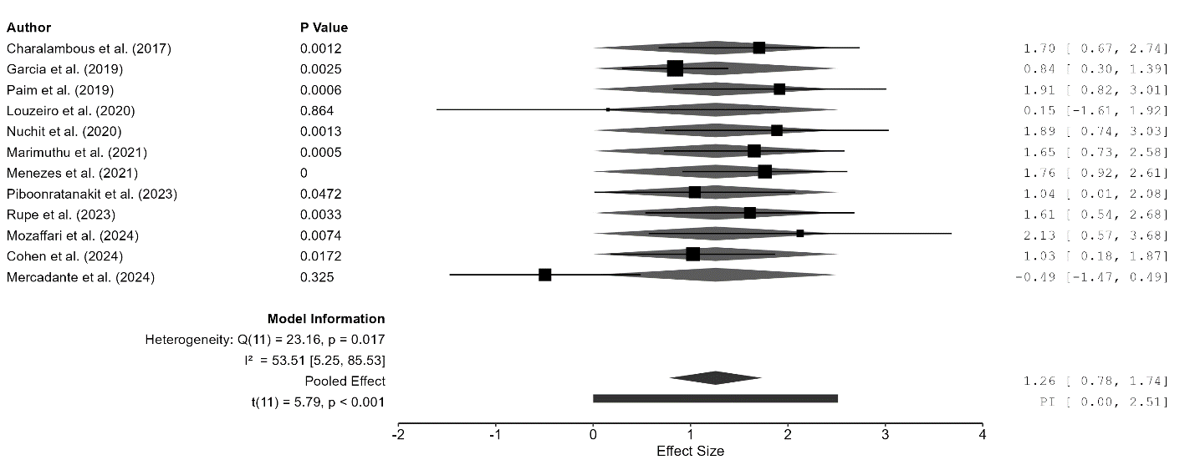
Figure 2. Forest Plot of the Effectiveness of Preventive and Therapeutic Interventions for Radiotherapy-Related Xerostomia
The forest plot results show that most articles demonstrated a positive direction of effect. The studies by Mozaffari et al. (2024), Paim et al. (2019), Nuchit et al. (2020), Menezes et al. (2021), Charalambous et al. (2017), and Marimuthu et al. (2021) are located on the right side of the zero line. This indicates that the interventions provided tended to have a better effect in reducing xerostomia or improving salivary function compared with the control groups. Louzeiro et al. (2020) showed a very small and unstable effect. Mercadante et al. (2024) was the only article showing a negative direction of effect. The pooled results showed a pooled effect of 1.26 with a CI of 0.78–1.74. The value of t(11) = 5.79 and p < 0.001 indicates that the pooled effect was statistically significant. The heterogeneity value of Q(11) = 23.16 with p = 0.017 and I² = 53.51% indicates moderate heterogeneity. This means that the variation in results across articles did not occur entirely due to random error. Differences in the type of intervention, timing of therapy, sample size, and instruments used to measure xerostomia may have contributed to this variation.
The funnel plot was used to assess the distribution of articles based on residual values and standard errors. It is used to determine whether study results are distributed evenly around the central line. A symmetrical distribution indicates a lower risk of publication bias. An asymmetrical distribution may suggest the possibility of publication bias, small-study effects, or heterogeneity across articles.
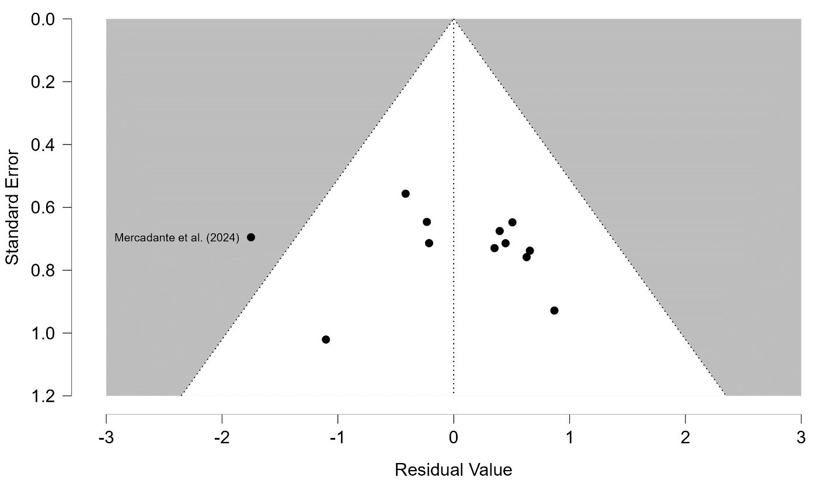
Figure 3. Funnel Plot of the Effectiveness of Preventive and Therapeutic Interventions for Radiotherapy-Related Xerostomia
The funnel plot shows that most articles are clustered around the central line and fall within the funnel area. This pattern indicates that most articles remain within an acceptable distribution. However, the distribution of points is not entirely symmetrical. Several articles are more concentrated on the right side of the central line. Mercadante et al. (2024) appears as the point that deviates the most to the left, with a large negative residual. This condition indicates that the article produced results that differ from the general tendency of the other articles. This difference is consistent with the forest plot, as Mercadante et al. (2024) also showed a negative effect direction and a non-significant main result. Overall, the funnel plot does not yet show strong symmetry. This may indicate the possibility of publication bias or heterogeneity in the results. The interpretation should remain cautious because the number of articles is only 12. This number is still relatively limited to strongly confirm the presence or absence of publication bias.
Discussion
The synthesis results indicate that preventive and therapeutic interventions for radiotherapy-related xerostomia in head and neck cancer patients provide a fairly consistent direction of benefit, although the magnitude of effect across articles is not uniform. The forest plot shows a pooled effect of 1.26, with a CI of 0.78–1.74 and p < 0.001. This value indicates a significant combined effect of various interventions on the improvement of xerostomia or salivary function. The heterogeneity value of I² = 53.51% indicates moderate variation among the articles. This variation is reasonable because the analyzed interventions are highly diverse, ranging from acupuncture, saliva substitutes, mouthwash, oral spray, photobiomodulation, electrical stimulation, to natural-product-based therapies. Garcia et al. (2019) and Cohen et al. (2024) showed strong evidence in favor of acupuncture. True acupuncture resulted in a greater reduction in xerostomia scores compared with standard care or standard oral hygiene. Menezes et al. (2021) also supported this pattern through a combination of traditional and auricular acupuncture, which reduced Xerostomia Inventory scores and improved saliva volume. These findings suggest that acupuncture is one of the relatively consistent non-pharmacological interventions for radiotherapy-induced xerostomia.
A comparison among interventions shows that saliva replacement and oral moisturizing therapies provide more direct benefits for oral comfort and swallowing function. Nuchit et al. (2020) demonstrated that oral moisturizing jelly and topical saliva gel both improved dry mouth complaints, swallowing ability, and nutritional status, with stronger outcomes observed in the oral moisturizing jelly group. Marimuthu et al. (2021) also reported that saliva substitute mouthwash reduced subjective xerostomia scores and increased unstimulated whole saliva in nasopharyngeal cancer survivors. Piboonratanakit et al. (2023) found that trehalose oral spray improved salivary pH and unstimulated salivary flow rate, although improvements in xerostomia-related quality of life were not always superior to those achieved with carboxymethylcellulose. Rupe et al. (2023) further showed that sodium-hyaluronate mouthwash reduced modified Xerostomia Questionnaire scores and increased patient satisfaction. These findings indicate that oral moisturizing interventions are closely aligned with patients’ symptomatic needs because their effects are felt in terms of dry mouth relief, swallowing comfort, and satisfaction with daily use.
Interventions that work through tissue or salivary gland stimulation show more varied results. Paim et al. (2019) reported that transcutaneous electrical nerve stimulation increased stimulated salivary flow, perceived salivary flow, and quality of life in patients with hyposalivation after radiotherapy. This result suggests that external electrical stimulation may serve as a promising therapeutic approach. Mercadante et al. (2024), however, reported different findings for intra-oral salivary electrostimulation. The primary outcome of LEONIDAS-2 was not achieved, and the difference between the active and sham devices was not significant, although there were signals of improvement in exploratory dry mouth indicators. The difference between the findings of Paim et al. (2019) and Mercadante et al. (2024) suggests that the effectiveness of electrical stimulation is likely influenced by device type, stimulation site, duration of use, residual salivary gland function, and the degree of radiation-induced damage. This finding is important because interventions with similar mechanisms do not necessarily produce the same clinical benefits.
Photobiomodulation also shows a pattern of results that is not yet fully stable. Mozaffari et al. (2024) found that photobiomodulation increased stimulated saliva and reduced subjective xerostomia in the final weeks of radiotherapy. This finding supports the role of photobiomodulation as a preventive intervention with the potential to preserve salivary function during treatment. Louzeiro et al. (2020), however, presented more cautious findings, as photobiomodulation did not show clear between-group differences in salivary flow, saliva composition, xerostomia, and quality of life, although salivary pH was better in the laser group. These differences may be due to variations in laser protocols, number of application points, energy, treatment frequency, measurement timing, and sample size. Charalambous et al. (2017) provided additional evidence from a natural intervention, showing that thyme honey reduced xerostomia and improved quality of life. The position of thyme honey in the comparison of effectiveness is not yet as strong as that of acupuncture or saliva substitutes because the available evidence remains limited, but its findings provide room for supportive therapies that are easily accepted by patients.
This systematic review and network meta-analysis show that no single intervention can be considered the most superior for all patient conditions. Acupuncture appears strong in reducing xerostomia symptoms, saliva substitutes and oral moisturizers are more relevant for improving oral comfort and swallowing function, while photobiomodulation is more promising as a preventive strategy during radiotherapy. Electrical stimulation produces mixed results, so its use should consider the type of device and the patient’s condition. The funnel plot shows a distribution of articles that is not fully symmetrical, with Mercadante et al. (2024) appearing as the point that deviates most from the general pattern. This condition reinforces the need for caution in interpreting the pooled results because the number of articles remains limited and the types of interventions are highly diverse. This synthesis provides a basis that the management of xerostomia in head and neck cancer patients should be selected according to the clinical phase, severity of symptoms, residual salivary function, and treatment goals. Preventive management should be directed toward preserving gland function from the beginning of radiotherapy, while post-radiotherapy therapy should aim to reduce symptoms, improve oral function, and enhance patients’ quality of life.
CONCLUSION
The findings of this study indicate that preventive and therapeutic interventions have the potential to reduce radiotherapy-related xerostomia in patients with head and neck cancer. Of the 12 articles analyzed, most interventions showed a positive effect on reducing dry mouth complaints, improving salivary function, or enhancing quality of life. The pooled effect of 1.26, with a CI of 0.78–1.74 and p < 0.001, indicates a significant combined effect. The I² value of 53.51% indicates moderate heterogeneity. Acupuncture, saliva substitutes, oral moisturizing agents, and mouthwash showed relatively consistent results. Photobiomodulation showed promising outcomes, particularly as a preventive approach. Electrical stimulation produced more varied results because not all devices generated the same clinical effect.
The implications of this study suggest that xerostomia management cannot be standardized for all patients. Preventive interventions are more appropriate when administered during radiotherapy to maintain salivary function. Therapeutic interventions are more directed toward patients who already experience chronic xerostomia or persistent dry mouth complaints after radiotherapy has been completed. These findings may help clinicians select supportive therapies that are more appropriate to the patient’s clinical phase. Acupuncture may be considered for chronic xerostomia complaints. Saliva substitutes, oral sprays, and mouthwash may be used to improve daily oral comfort. Photobiomodulation may be considered in healthcare facilities with adequate resources and therapeutic protocols.
The limitations of this study lie in the variation in intervention types, research designs, sample sizes, measurement instruments, and evaluation times across the articles. Some articles also used continuous outcomes, such as xerostomia scores and salivary flow rates, so the process of standardizing effect sizes needed to be conducted carefully. The limited number of articles also means that the interpretation of the funnel plot and the potential for publication bias cannot yet be concluded strongly. Future studies are recommended to use randomized clinical trials with larger samples, more uniform intervention protocols, longer follow-up periods, and more complete data reporting. Simultaneous reporting of OR, CI, p-value, xerostomia scores, salivary flow rates, and quality of life will facilitate a stronger synthesis of evidence in the future.
REFERENCES
Alnaeem, M. M., Darwish, S. K., & Nashwan, A. J. (2025). Radiation-induced xerostomia in head and neck cancers: A comprehensive review for burden and impact on nutrition, sleep, and quality of life. Discover Medicine, 2, 143. https://doi.org/10.1007/s44337-025-00362-1
Charalambous, A., Lambrinou, E., Katodritis, N., Vomvas, D., Raftopoulos, V., Georgiou, M., Paikousis, L., Charalambous, M., & Kouloulias, V. (2017). The effectiveness of thyme honey for the management of treatment-induced xerostomia in head and neck cancer patients: A feasibility randomized control trial. European Journal of Oncology Nursing, 27, 1–8. https://doi.org/10.1016/j.ejon.2017.01.001
Cohen, L., Garcia, M. K., Lee, R., Haddad, R., Lee, N. Y., Chen, Y. H., & Rosenthal, D. I. (2024). Acupuncture for chronic radiation-induced xerostomia in head and neck cancer: A multicenter randomized clinical trial. JAMA Network Open, 7(5), e248725. https://doi.org/10.1001/jamanetworkopen.2024.8725
Garcia, M. K., Meng, Z., Rosenthal, D. I., Shen, Y., Chambers, M., Yang, P., Wei, Q., Hu, C., Wu, C., Bei, W., Prinsloo, S., Chiang, J., Lopez, G., & Cohen, L. (2019). Effect of true and sham acupuncture on radiation-induced xerostomia among patients with head and neck cancer: A randomized clinical trial. JAMA Network Open, 2(12), e1916910. https://doi.org/10.1001/jamanetworkopen.2019.16910
Gu, J., Zhu, S., Li, X., Wu, H., Li, Y., & Hua, F. (2014). Effect of amifostine in head and neck cancer patients treated with radiotherapy: A systematic review and meta-analysis. PLOS ONE, 9(5), e95968. https://doi.org/10.1371/journal.pone.0095968
Higgins, J. P. T., Thomas, J., Chandler, J., Cumpston, M., Li, T., Page, M. J., & Welch, V. A. (Eds.). (2024). Cochrane handbook for systematic reviews of interventions (Version 6.5). Cochrane. https://training.cochrane.org/handbook
Hong, C., Jensen, S. B., Vissink, A., Bonomo, P., Santos-Silva, A. R., Gueiros, L. A., Epstein, J. B., & Elad, S. (2024). MASCC/ISOO clinical practice statement: Management of salivary gland hypofunction and xerostomia in cancer patients. Supportive Care in Cancer, 32, 548. https://doi.org/10.1007/s00520-024-08688-9
Jaguar, G. C., Lima, E. N. P., Kowalski, L. P., Pellizzon, A. C. A., Carvalho, A. L., & Alves, F. A. (2017). Clinical features and preventive therapies of radiation-induced xerostomia in head and neck cancer patient: A literature review. Applied Cancer Research, 37, 31. https://doi.org/10.1186/s41241-017-0037-5
Louzeiro, G. C., Cherubini, K., de Figueiredo, M. A. Z., & Salum, F. G. (2020). Effect of photobiomodulation on radiotherapy-induced xerostomia and hyposalivation: A systematic review and meta-analysis. Supportive Care in Cancer, 28, 2911–2921.
Marimuthu, D., Han, K. M., Mohamad, M. S. F., & Azman, M. (2021). Saliva substitute mouthwash in nasopharyngeal cancer survivors with xerostomia: A randomized controlled trial. Clinical Oral Investigations, 25, 3105–3115. https://doi.org/10.1007/s00784-020-03634-5
Menezes, A. S. da S., Sanches, G. L. G., Gomes, E. S. B., Soares, R. G., Durães, C. P., Fonseca, L. L., Filho, A. P. S., Ribeiro, A. A. A. A., Nascimento, J. E., Santos, S. H. S., de Paula, A. M. B., Farias, L. C., & Guimarães, A. L. S. (2021). The combination of traditional and auricular acupuncture to prevent xerostomia and anxiety in irradiated patients with HNSCC: A preventive, parallel, single-blind, 2-arm controlled study. Oral Surgery, Oral Medicine, Oral Pathology and Oral Radiology, 131(6), 675–683. https://doi.org/10.1016/j.oooo.2021.02.016
Mercadante, V., Al Hamad, A., Lodi, G., Porter, S., & Fedele, S. (2017). Interventions for the management of radiotherapy-induced xerostomia and hyposalivation: A systematic review and meta-analysis. Oral Oncology, 66, 64–74. https://doi.org/10.1016/j.oraloncology.2016.12.031
Mercadante, V., Hamad, A. A., McCaul, J., Nutting, C., Harrington, K., Carnell, D., Katre, C., Megson, M., Slevin, N., Elliott, M., Foster, C., Mills, W., Beare, S., Porter, S., & Fedele, S. (2024). Salivary electrostimulation in the treatment of radiation therapy-induced xerostomia (LEONIDAS-2): A multicenter, randomized, double-masked, sham-controlled, phase 3 trial. International Journal of Radiation Oncology, Biology, Physics, 118(1), 142–153. https://doi.org/10.1016/j.ijrobp.2023.03.047
Mercadante, V., Jensen, S. B., Smith, D. K., Bohlke, K., Bauman, J., Brennan, M. T., Coppes, R. P., Jessen, N., Malhotra, N. K., Murphy, B., Rosenthal, D. I., Vissink, A., Wu, J., Saunders, D. P., & Peterson, D. E. (2021). Salivary gland hypofunction and/or xerostomia induced by nonsurgical cancer therapies: ISOO/MASCC/ASCO guideline. Journal of Clinical Oncology, 39(25), 2825–2843. https://doi.org/10.1200/JCO.21.01208
Mozaffari, P. M., Esmaeilzadeh, M., Rahimian, S., Shirani, A. M., Babaei, M., Amiri, F., Asnaashari, M., & Mehdizadeh, M. (2024). Evaluation of the effect of photobiomodulation on radiation-induced xerostomia in head and neck cancer patients: A randomized clinical trial. Journal of Lasers in Medical Sciences, 15, e4. https://doi.org/10.34172/jlms.2024.04
Nakamura, N., Sasano, N., Yamashita, H., Shiraishi, K., & Murakami, M. (2023). Preventive and therapeutic effects of bethanechol chloride on radiation-induced xerostomia in head and neck cancer patients. Oral Oncology, 140, 106387.
Nathan, C. A. O., Asarkar, A. A., Entezami, P., Corry, J., Strojan, P., Vander Poorten, V., Mäkitie, A., Eisbruch, A., Robbins, K. T., Smee, R., St. John, M., Paleri, V., & Ferlito, A. (2023). Current management of xerostomia in head and neck cancer patients. Oral Oncology, 138, 106304.
Ni, X., Tian, T., Chen, D., Liu, Y., & Li, H. (2020). Acupuncture for radiation-induced xerostomia in cancer patients: A systematic review and meta-analysis. Integrative Cancer Therapies, 19, 1–13.
Nuchit, S., Lam-Ubol, A., Paemuang, W., Talungchit, S., Chokchaitam, O., Mungkung, O., Pongcharoen, T., & Trachootham, D. (2020). Alleviation of dry mouth by saliva substitutes improved swallowing ability and clinical nutritional status of post-radiotherapy head and neck cancer patients: A randomized controlled trial. Supportive Care in Cancer, 28(6), 2817–2828. https://doi.org/10.1007/s00520-019-05132-1
Page, M. J., McKenzie, J. E., Bossuyt, P. M., Boutron, I., Hoffmann, T. C., Mulrow, C. D., Shamseer, L., Tetzlaff, J. M., Akl, E. A., Brennan, S. E., Chou, R., Glanville, J., Grimshaw, J. M., Hróbjartsson, A., Lalu, M. M., Li, T., Loder, E. W., Mayo-Wilson, E., McDonald, S., & Moher, D. (2021). The PRISMA 2020 statement: An updated guideline for reporting systematic reviews. BMJ, 372, n71. https://doi.org/10.1136/bmj.n71
Paim, É. D., Zanella, V. G., Martins, V. B., Macagnan, F. E., & Berbert, M. C. B. (2019). Effects of transcutaneous electrical nerve stimulation on the salivary flow of patients with hyposalivation induced by radiotherapy in the head and neck region: A randomized clinical trial. Journal of Oral Rehabilitation, 46(12), 1142–1150. https://doi.org/10.1111/joor.12851
Piboonratanakit, P., Ferreira, J. N., Pravinvongvuthi, K., Maison, K., Urkasemsin, G., Boonroung, T., Prayongrat, A., Lertbutsayanukul, C., Sucharitakul, J., & Vacharaksa, A. (2023). Trehalose versus carboxymethylcellulose oral spray for relieving radiation-induced xerostomia in head and neck cancer patients: A randomized controlled trial. BMC Oral Health, 23, 288. https://doi.org/10.1186/s12903-023-02966-4
Rupe, C., Basco, A., Gioco, G., Patini, R., Lucchese, A., Miccichè, F., Massaccesi, M., & Lajolo, C. (2023). Sodium-hyaluronate mouthwash on radiotherapy-induced xerostomia: A randomised clinical trial. Supportive Care in Cancer, 31, 644. https://doi.org/10.1007/s00520-023-08090-x
Shrateh, Z. A., Alrabadi, N., Abuhammad, S., & Alomari, M. (2025). Therapeutic interventions for radiation-induced xerostomia in head and neck cancer patients: A systematic review and meta-analysis. Supportive Care in Cancer, 33, 1–15.
Sun, H., Zheng, R., Zhang, S., Zeng, H., Chen, R., & He, J. (2025). Global burden of head and neck cancer in 2022 and projections to 2050. Frontiers in Public Health, 13, 1555050.
Tsai, R. Y., Lin, S. Y., Chen, C. C., & Hsiao, Y. (2025). Efficacy of acupuncture in managing radiation-induced xerostomia: An updated meta-analysis. International Journal of Medical Sciences, 22(11), 2802–2815. https://doi.org/10.7150/ijms.110366
Yang, W. F., Liao, G. Q., Hakim, S. G., Ouyang, D. Q., Ringash, J., & Su, Y. X. (2016). Is pilocarpine effective in preventing radiation-induced xerostomia? A systematic review and meta-analysis. International Journal of Radiation Oncology, Biology, Physics, 95(2), 591–599.

